Nike FI Flex

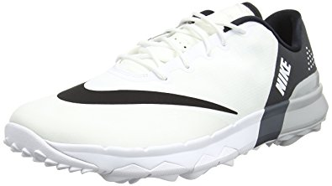

Product code: 1026

The Nike FI Flex Women's Golf Shoe flexes with your foot for a smooth, natural feel and features lightweight cushioning to help keep you comfortable through to the eighteenth hole.

# Nike Lunar Control Vapor

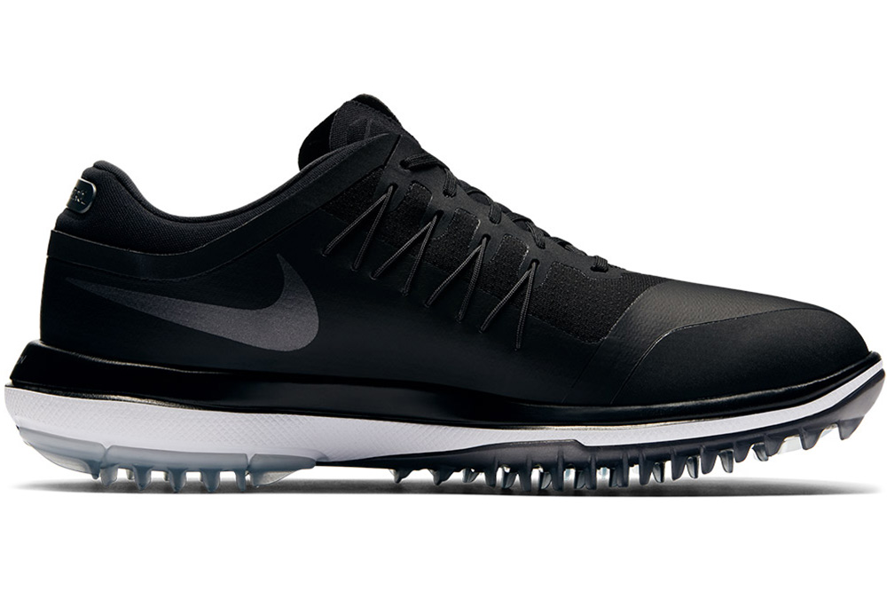

Product code: 1027

The Nike Lunar Control Vapor (Wide) Women's Golf Shoe features a waterproof upper to help you stay dry and an Articulated Integrated Traction pattern to help stabilise your swing and offer traction in all conditions.

# Nike Lunar Command 2

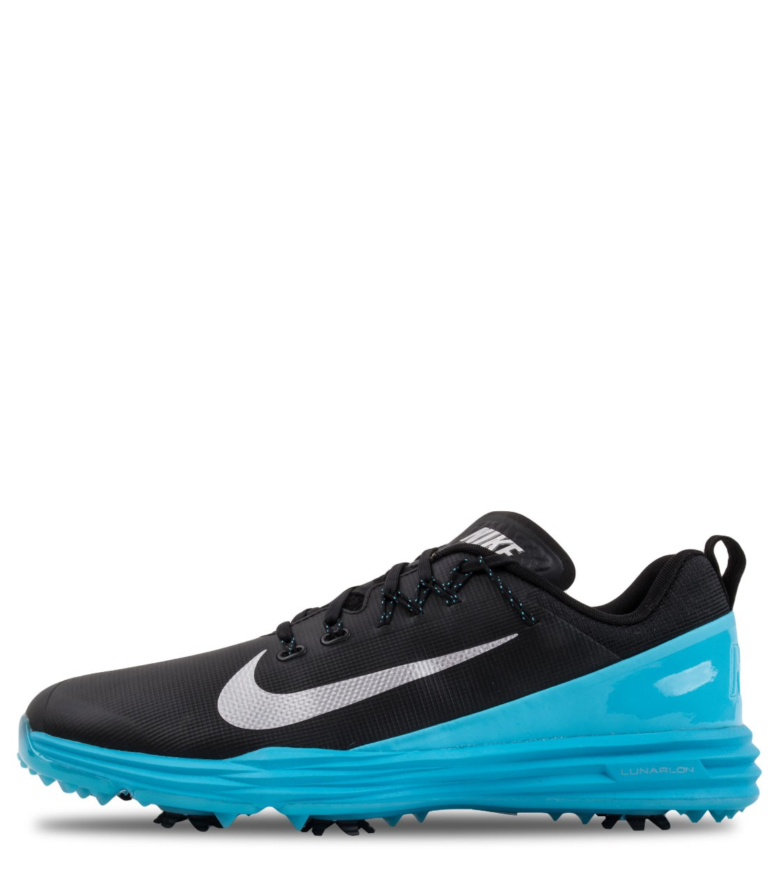

Product code: 1028

The Nike Lunar Command 2 Women's Golf Shoe is made with Flywire technology and a Lunarlon midsole for adaptive support and springy cushioning from your first drive to your final putt.

# Nike Lunar Control Vapor 2

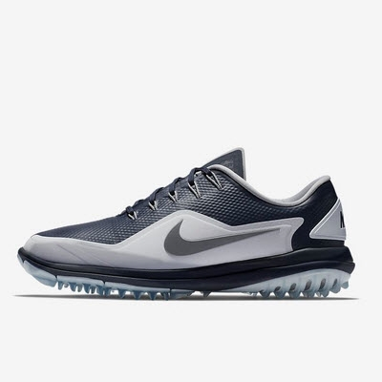

Product code: 1029

The Nike Lunar Control Vapor 2 Women's Golf Shoe delivers the grip, support and comfort you need to drive further off the tee.

# Nike Air Zoom 90 IT

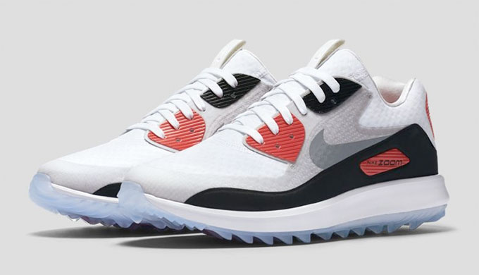

Product code: 1030

An updated favourite of Rory McIlroy's, the Nike Air Zoom 90 IT Women's Golf Shoe features a waterproof upper and incredible traction for those who don't let the weather stand in their way.